44.19: 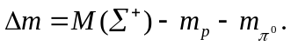 Using Table (44.3):
